**Fridays from 11AM- 1:30 PM Midwest Insurance Corp (MIC)**

**Parking Lot**

**1601 S B Ave, Nevada**

**When: Where:**

7/22- Hungry Boys

7/29- Karam’s Mediterranean Grill

8/05- Two Ol’ Chefs

8/12- Meat Wagon

8/19- Nacho Daddyz Tacos

8/26- Street Eats DSM

9/02- Smokin' Critters BBQ

6/03- Smokin' Critters

6/10- Hotsy Totsy

6/17- Eat It Ames

6/24- Carlos Quesadillas

7/01- Sooks Korean Kitchen

7/08- Comfort Foods of Huxley 7/15- Ally’s Sandwiches & Wraps

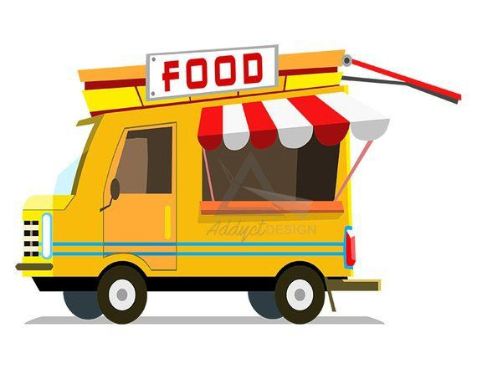

**Food Truck Friday at MIC!**

**Join us in supporting local area food trucks.**

**Open to the public!**

**Food Truck Friday**